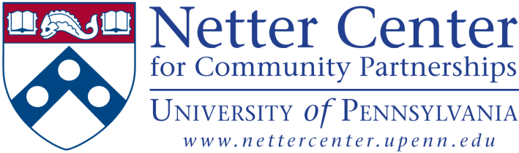

SUMMER 2015 JOB OPPORTUNITIES WITH THE NETTER CENTER FOR COMMUNITY PARTNERSHIPS
Undergraduates at $10/hr
Graduates at $12/hr

Agatston Urban Nutrition Initiative
AUNI Youth Development program provides paid internships to approximately 100 high school students during the summer. For 6 weeks during the summer, AUNI empowers teen interns to explore and identify solutions to the problem of urban American health disparities via their placement in either peer nutrition education or urban agriculture worksites. We are looking for energetic, reliable, and passionate young adults (Penn students and UNI high school alumni) to join the UNI team for the summer as assistants to Youth Development Staff. Depending on performance and interest, there is also possibility of position continuing into the fall. Positions include:

- Cooking Crew Program Associate
- Garden Crew Program Associate
- College Access and Career Readiness Program Associate/Mentor
- Farm Fellow/Apprentice

For more information, please contact: aunistudentengagement@gmail.com

University-Assisted Community Schools (UACS) Programming
Currently seeking applications for full-time and part-time summer positions including:
- Huey School (K-8): Program Associates to assist with STEM & Literacy Program
- Comegys School (K-8): Full-time & Part-Time Program Associates
- Lea School (K-8): Servant Leader Interns, Assistant Teacher, Enrichment Club Specialist
- Sayre School (9-12): Cross-Grade Literacy Program Associates, Social Entrepreneurship Research Associates, and Summer Bridge Program Associate

For more information on each position: please refer to the job descriptions on SEMS (see bottom of page).

Rebel Ventures
Rebel Ventures (www.rvcrew.com) is a social entrepreneurship and youth development project under AUNI that creates products to support a sustainable, just, and community-based food system. Summer positions include:

- Design Manager
- Brand Manager
- Social Media Manager
- Operations Manager
- Sales Manager
- Administrative/Program Manager
- Enrichment Coordinator
- Outreach Coordinator

For more information, contact: stein.jarrett@gmail.com

Young Quakers & UACS Sports Program
Penn students will support academic tutoring, mentoring and development of sports skills for elementary and middle school students who are participating in the Young Quakers Community Athletics & UACS Sports programs. Summer positions include:

- Sports Camp Program Associate (YQCA)
- Sports Programming Research Associate (YQCA)
- Sports & Games Program Associate (UACS Sports)

For more information, contact: Jennifer Chu (YQCA) at jenx@sas.upenn.edu or Paulette Branson (UACS Sports) at pbran@sas.upenn.edu.

Evaluation Data Team
The Netter Center Evaluation Team is currently seeking candidates for full‐time and part‐time positions to support quantitative and qualitative research and evaluation of Netter Center programs and initiatives. Tasks may include development of evaluation framework, literature reviews, conducting interviews and focus groups, survey development and administration, data management, qualitative and quantitative data analysis, and report writing. Opportunities are available for driven, self-motivated undergraduate and graduate students to begin this summer. Research experience preferred, but not required. Positions include:

- Associate Office Manager
- Database Development Associate
- Android Application Coder
- Qualitative Data Managers (K-8 & 9-12)
- Associate Analysts for Young Quakers, Pipeline, and ABCS

Interested applicants to apply at: applytonccpevaluation@gmail.com.

For more information on each position, please reference the Penn Student Job Board on the Student Financial Services Site using keyword “Netter Center.”

