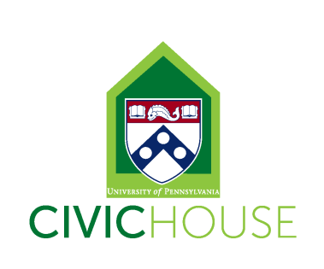
Civic House Communications and Outreach Coordinator (Work-Study Position)
10-15 hours a week
The Communications and Outreach Coordinator will provide support to a variety of Civic House initiatives related to community engagement and social justice. Among other efforts, the position will involve working collaboratively to create meaningful and intentional engagement, learning, and leadership opportunities, while also strengthening the Civic House community and civic engagement at Penn. Civic House is a vibrant community committed to student development and mentorship of all student staff.
Position Description:
All student staff will support Civic House by answering phones, greeting guests, maintaining the facilities and helping to oversee the house during the evening hours. In addition to general Civic House responsibilities, specific projects for this position include supporting Civic House Programming and major events.
In addition to general Civic House responsibilities, specific projects for this position include:
- Managing Civic House’s official Facebook and Twitter pages and growing all elements of Civic House’s social media presence.
- Creating and maintaining Civic House’s weekly newsletter
- Maintaining Civic House website and making regular updates to primary webpages
- Creating and maintaining an integrated and active approach to Civic House’s social media and traditional marketing strategies.
- Interviewing students, alumni and community partners for regular spotlights
- Soliciting Civic House staff, students and partners for relevant content to be included on social media marketing.
- Coordinate Student Staff to implement outreach plan including scheduling student staff outreach of Flyering on Locust Walk, posting flyers in dorms and across campus etc.
- Staying informed of relevant current events, campus news, and community partner updates for inclusion on website and/or in newsletters.
- Having regular communication with and availability for weekly meetings with supervisor and bi-monthly working group meetings and monthly all staff meetings.
Individual must be innovative, self-motivated and able to work independently and creatively. Experience using social media tools such as Facebook, Twitter, and Hootsuite for professional purposes is desired, but not required. Strong applicants will also be organized, detail-oriented, flexible and reliable. The ideal candidate will possess all of these attributes and have community engagement experience at Penn and be willing to work 10-15 hours.
To Apply: Send an email indicating interest and availability with your resume to Elizabeth Cannon, cannone@upenn.edu.
***All staff are required to attend our September 2nd Student Staff Training (time TBD), Civic House IGNITE Retreat (September 9th-11th), and twice a month staff and Civic House Working Group meetings Fridays from 2-4pm (9/23, 10/14, 10/21, 11/4, 11/18 & 12/2)***

