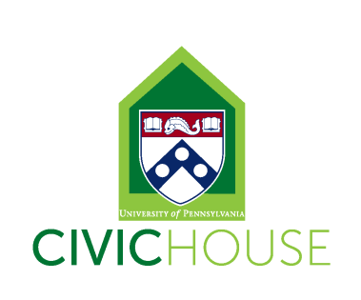
Civic House Community Partner Liaison
(Work-Study Position)
10-15 hours a week
The Community Partner Liaison will provide support to build and strengthen mutually beneficial relationships between Civic House and its community partners. Community Partner Liaisons will serve as campus liaisons to our local non-profit community partners by helping to build long-term sustainable partnerships through student volunteer recruitment and retention. Liaisons will work to educate the campus community about the organization’s work, while also helping to recruit, train, and manage Penn volunteers for engagement with the organization.
As part of a team of Civic House student staff members, Community Partner Liaison’s will work collaboratively to create meaningful and intentional engagement, learning, and leadership opportunities, while also strengthening the Civic House community and civic engagement at Penn. Civic House is a vibrant community committed to student development and mentorship of all student staff.
Community Partner Liaisons will support the organizations by engaging with partner organizations on-site, as well as at Civic House. For the portion of hours at Civic House, Community Partner Liaisons will help by answering phones, greeting guests, maintaining the facilities and helping to oversee the house during the evening hours.
Position Description: The Community Partner Liaison will work in collaboration with Civic House full time and student staff to coordinate volunteer opportunities for Penn students to engage with our community partner organizations. In addition, Community Partner Liaisons will provide administrative support in communicating with community partners, training and scheduling volunteers, and coordinating of one-time service projects.
Applicants for this position should work well independently, possess strong computer skills, and be very organized, detail-oriented and reliable. The ideal candidate will have community engagement experience at Penn. Experience with event planning and facilitation is also a plus, but not required.
We are looking for students with the following interests and skills:
- Experience with civic engagement, service and advocacy at Penn and/or work in service-learning/Academically Based Community Service classes.
- Familiarity with the Philadelphia area and/or local nonprofits and demonstrated ability to work with community partners.
- Willingness to take initiative as well as accept direction from Civic House staff.
- Detail oriented with strong organizational skills.
- Demonstrated ability with event/project planning and execution.
- Experience facilitating group discussions and workshops
To Apply: Send an email indicating interest and availability with your resume to civic@dolphin.upenn.edu. Please also indicate the number of hours you are interested in working (10-15).
All staff are required to attend our September 2nd Student Staff Training (time TBD), Civic House IGNITE Retreat (September 9th-11th), and Civic House staff meetings Fridays from 2-4pm (10/14, 11/4 & 12/2).

