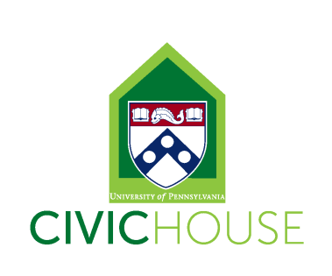
Civic House Design and Outreach Coordinator (Work-Study Position)
10-15 hours a week
The Design and Outreach Coordinator will provide support to a variety of Civic House initiatives related to community engagement and social justice. Among other efforts, the position will involve working collaboratively to create meaningful and intentional engagement, learning, and leadership opportunities, while also strengthening the Civic House community and civic engagement at Penn. Civic House is a vibrant community committed to student development and mentorship of all student staff.
Position Description:
All student staff will support Civic House by answering phones, greeting guests, maintaining the facilities and helping to oversee the house during the evening hours. In addition to general Civic House responsibilities, specific projects for this position include supporting Civic House Programming and major events.
In addition to general Civic House responsibilities, this student staff member will be a member of a 2-person Communications and Outreach Team. Some responsibilities and projects for this team may include:
- Designing flyers, posters brochures, invitations in support of Civic House programs
- Photographing Civic House events
- Maintaining and growing the presence of the new Civic House Blog, Seeds to Revolution as well as gathering and curating content for the blog.
- Managing Civic House’s official Facebook and Twitter pages and growing all elements of Civic House’s social media presence.
- Creating and maintaining Civic House’s weekly newsletter
- Maintaining Civic House website and making regular updates to primary webpages
- Creating and maintaining an integrated and active approach to Civic House’s social media and traditional marketing strategies.
- Interviewing students, alumni and community partners for regular spotlights
- Soliciting Civic House staff, students and partners for relevant content to be included on social media marketing.
- Coordinate Student Staff to implement outreach plan including scheduling student staff outreach of Flyering on Locust Walk, posting flyers in dorms and across campus etc.
- Staying informed of relevant current events, campus news, and community partner updates for inclusion on website and/or in newsletters.
- Having regular communication with and availability for weekly meetings with supervisor and bi-monthly working group meetings and monthly all staff meetings.
Individual must be innovative, self-motivated and able to work both independently and as a member of a team. Experience with Adobe design software and photography required. Video and editing experience a plus. Experience using social media tools such as Facebook, Twitter, and Hootsuite for professional purposes is desired, but not required. Strong applicants will also be organized, detail-oriented, flexible and reliable. The ideal candidate will possess all of these attributes and have community engagement experience at Penn and be willing to work 10-15 hours/week.
To Apply: Send an email indicating interest and availability with your resume to Elizabeth Cannon, cannone@upenn.edu. There is a rolling deadline; however, for best consideration, please submit application by August 25th.***All staff are required to attend our September 2nd Student Staff Training (time TBD), Civic House IGNITE Retreat (September 9th-11th), and twice a month staff and Civic House Working Group meetings Fridays from 2-4pm (9/23, 10/14, 10/21, 11/4, 11/18 & 12/2)***

