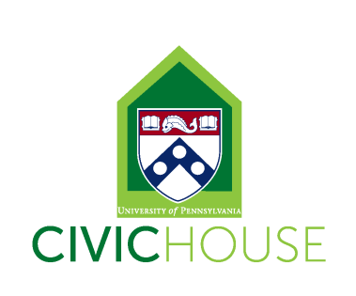
Civic House Development and Alumni Assistant (Work-Study Position)
10-15 hours a week
The Development and Alumni Assistant will report to the Director and provide support to a variety of Civic House initiatives related to community engagement and social justice. Among other efforts, the position will involve working collaboratively to create meaningful and intentional engagement, learning, and leadership opportunities, while also strengthening the Civic House community and civic engagement at Penn. Civic House is a vibrant community committed to student development and mentorship of all student staff.
Position Description:
All student staff will support Civic House by answering phones, greeting guests, maintaining the facilities and helping to oversee the house during the evening hours. In addition to general Civic House responsibilities, specific projects for this position include supporting Civic House Programming and major events.
In addition to general Civic House responsibilities, specific projects for this position include:
- Plan and Draft content for quarterly E-Newsletter to all alumni
- Help design and create a database for tracking alumni engagement
- Update alumni website with upcoming events, update alumni profiles, add pictures etc.
- Provide planning and logistical support for alumni events including Homecoming and the annual Alumni and Senior Reception as well as local and regional engagement with alumni
- Support the early stages of planning for Civic House’s 20th anniversary
- Help to receive and process gifts
- Support Office Coordinator with other facilities needs and logistics as needed.
- Review best practices, vision and create a plan to revamp the Civic House LinkedIn page, grow our use of LinkedIn
- Having regular communication with and availability for weekly meeting with supervisor and other stakeholders
Individual must be innovative, self-motivated and able to work independently and creatively. Strong applicants will also be organized, detail-oriented, flexible and reliable. The ideal candidate will possess all of these attributes, have community engagement experience at Penn and be willing to work 8-15 hours.
To Apply: Send an email indicating interest and availability with your resume to Elizabeth Cannon, cannone@upenn.edu.
***All staff are required to attend our September 2nd Student Staff Training (time TBD), Civic House IGNITE Retreat (September 9th-11th), and twice a month staff and Civic House Working Group meetings Fridays from 2-4pm (9/23, 10/14, 10/21, 11/4, 11/18 & 12/2)***

