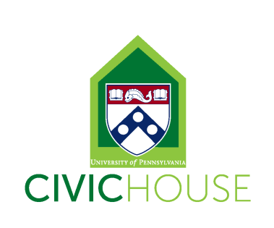
Civic House Program Assistant (Work-Study Position)
8-15 hours a week
The Program Assistant will provide support to a variety of Civic House initiatives related to community engagement and social justice. Among other efforts, the position will involve working collaboratively to create meaningful and intentional engagement, learning, and leadership opportunities, while also strengthening the Civic House community and civic engagement at Penn. Civic House is a vibrant community committed to student development and mentorship of all student staff.
All student staff will support Civic House by answering phones, greeting guests, maintaining the facilities and helping to oversee the house during the evening hours. In addition to general Civic House responsibilities, specific projects for this position include supporting Civic House Programming and major events.
Position Description: The Program Assistant will work in collaboration with Civic House full time and student staff to plan and implement Civic House programming including but not limited to our ongoing engagement, education and reflection spaces (i.e. social justice workshops, informal spaces, major events, Open Forum, Civic House Blog, MLK Day, etc.). In addition, Program Assistants will provide administrative support for Civic House core programs: West Philadelphia Tutoring Project, The Community Engagement Internship Program, Alternate Spring Break, Civic Scholars and Public Interest Career Workshops.
Applicants for this position should work well independently, possess strong computer skills, and be very organized, detail-oriented and reliable. The ideal candidate will have community engagement experience at Penn. Experience with event planning and facilitation is also a plus, but not required.
We are looking for students with the following interests and skills:
- Experience with civic engagement, service and advocacy at Penn and/or work in service-learning/Academically Based Community Service classes.
- Familiarity with the Philadelphia area and/or local nonprofits and demonstrated ability to work with community partners.
- Willingness to take initiative as well as accept direction from Civic House staff.
- Detail oriented with strong organizational skills.
- Demonstrated ability with event/project planning and execution.
- Experience facilitating group discussions and workshops
To Apply: Send an email indicating interest and availability with your resume to civic@dolphin.upenn.edu. Please also indicate the number of hours you are interested in working (8-15).
All staff are required to attend our September 2nd Student Staff Training (time TBD), Civic House IGNITE Retreat (September 9th-11th), and twice a month staff and Civic House Working Group meetings Fridays from 2-4pm (9/23, 10/14, 10/21, 11/4, 11/18 & 12/2)

