Penn Dental  Queer Alliance  lgbtq.penndental@gmail.com | Penn Dental Queer Alliance is a student-lead LGBTQ Alliance for Penn Dental Students. Its goal is to promote a safe and inclusive atmosphere for community members of all gender expressions and sexualities at Penn Dental Medicine.
lambdagrads@gmail.com | Lambda Grads is the umbrella LGBTQ organization for graduate and professional students at the University of Pennsylvania. We organize a wide range of professional, academic, and community-building programming throughout the year in order to bring about greater awareness to LGBT issues and interests.
lambda@law.upenn.edu | Lambda Law is open to students, faculty, and staff of the Law School. Lambda Law meets regularly for social events and political activities. They work to represent LGBT concerns in academia and in  the wider community.
LAMBDA VETS  vetstudents@lgvma.org | LambdaVets is a PennVet-VOICE affiliated student run group that aims to increase awareness, understanding, and acceptance of the veterinary field’s sexual and gender minority members. From clients to colleagues, we strive to provide a forum for information exchange and social interaction with the goal of fostering a professional climate in which our members can achieve their full potential.
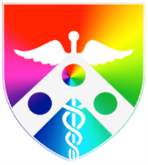  lgbtpmleaders@gmail.com  @PennMedLGBTQPM | LGBTTPM+ (Lesbian Gay Bisexual Transgender People in Medicine) is the name of an active advocacy committee within the national American Medical Student Association. A faculty and staff committee has work closely with the students around LGBTQ concerns in medicine and to address additional issues.
o4b.confidential@wharton.upenn.edu @WhartonOut4Biz | Out For Business is Wharton's lesbian, gay, bisexual, transgender, and queer club for MBA and PhD students, faculty, and staff. Out4Biz aims to create an open and inclusive community that fosters the development and success of LGBTQ people and LGBTQ allies in business.
GSEOutED@gmail.com  @UPennOutEd | OutEd is the Graduate School of Education's LGBT and ally student group offering support to queer Grad Ed students as well as providing educational opportunities for the school regarding queer issues.
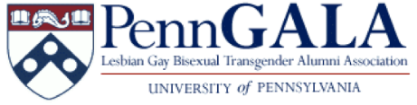  ecross@upenn.edu | PennGALA (Penn Gay Lesbian Bisexual Transgender Alumni Association) represents the interests of the University's LGBTQ alumni by fostering a sense of community, promoting a close relationship between the alumni and the University, and advocating for current LGBTQ students.
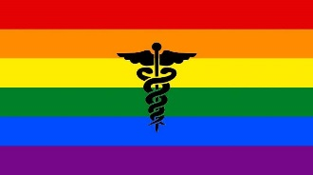  pennprideatHUP@uphs.upenn.edu  @pennprideatHUP | PennPRIDE@HUP is an interdisciplinary employee-based resource group comprised of individuals at The Hospital of the University of Pennsylvania and their associated networks, who seek to promote excellence in LGBTQ health - including improved patient experience and employee satisfaction.
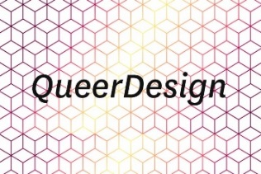  qdesign@design.upenn.edu | QueerDesign hopes to build a community of LGBTQ+ designers in order to create a space of exchange and judgement free collaboration. Aiming to foster discussions about the meaning of diversity, and its intersection with design at Penn and beyond, QueerDesign hopes to connect to existing networks of students and professionals.
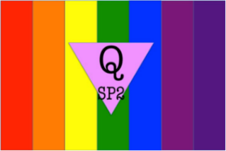  contactqsp2@gmail.com | QSP2 is a group created to represent LGBTQIA+ students and allies of the SP2 community. The group's purpose is to offer social activities, advocate for LGBTQ rights and services in the School of Social Policy & Practice (SP2), and to serve as a group within the University-wide network of LGBTQ organizations at Penn.

LGBT Center | University of Pennsylvania |3907 Spruce Street | Philadelphia, PA 19104 | 215-898-5044
For more information, contact Tiffany Thompson, ttiff@upenn.edu

