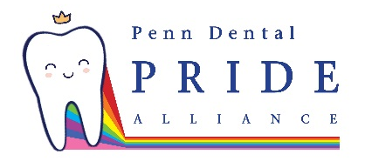  lgbtq.penndental@gmail.com | Penn Dental Pride Alliance mission is to unify and support LGBTQ+ dental students, faculty, administration, staff, and their supporters. Our goal is to achieve this through school-wide diversity and inclusion efforts, consistent educational programming, and entertaining events that enrich our community.
lambdagrads@gmail.com | Lambda Grads is the umbrella LGBTQ organization for graduate and professional students at the University of Pennsylvania. We organize a wide range of professional, academic, and community-building programming throughout the year in order to bring about greater awareness to LGBT issues and interests.
lambda@law.upenn.edu | Lambda Law is open to students, faculty, and staff of the Law School. Lambda Law meets regularly for social events and political activities and work to represent LGBT concerns in academia and the wider community.
LAMBDA VETS  vetstudents@lgvma.org | LambdaVets is a PennVet-VOICE affiliated student run group that aims to increase awareness, understanding, and acceptance of the veterinary field’s sexual and gender minority members. From clients to colleagues, we strive to provide a forum for information exchange and social interaction with the goal of fostering a professional climate in which our members can achieve their full potential.
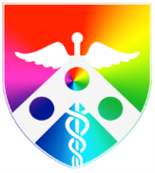  lgbtpmleaders@gmail.com  @PennMedLGBTQPM | LGBTTPM+ (Lesbian Gay Bisexual Transgender People in Medicine) is the name of an active advocacy committee within the national American Medical Student Association. A faculty and staff committee has work closely with the students around LGBTQ concerns in medicine and to address additional issues.
o4b.confidential@wharton.upenn.edu @WhartonOut4Biz | Out For Business is Wharton's lesbian, gay, bisexual, transgender, and queer club for MBA and PhD students, faculty, and staff. Out4Biz aims to create an open and inclusive community that fosters the development and success of LGBTQ people and LGBTQ allies in business.
GSEOutED@gmail.com  @UPennOutEd | OutEd is the Graduate School of Education's LGBT and ally student group offering support to queer Grad Ed students as well as providing educational opportunities for the school regarding queer issues.
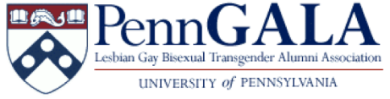  ecross@upenn.edu | PennGALA (Penn Gay Lesbian Bisexual Transgender Alumni Association) represents the interests of the University's LGBTQ alumni by fostering a sense of community, promoting a close relationship between the alumni and the University, and advocating for current LGBTQ students.
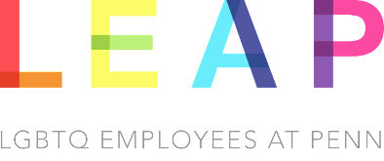  ttiff@upenn.edu | LEAP (LGBT Employees at Penn) addresses concerns of Penn's LGBT staff and faculty, sponsors social and informational events, and hold meetings periodically. To be added to the listserv, contact the LGBT Center.
pennprideatHUP@uphs.upenn.edu  @pennprideatHUP | PennPRIDE@HUP is an interdisciplinary employee-based resource group comprised of individuals at The Hospital of the University of Pennsylvania and their associated networks, who seek to promote excellence in LGBTQ health - including improved patient experience and employee satisfaction.
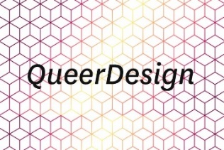  qdesign@design.upenn.edu | QueerDesign hopes to build a community of LGBTQ+ designers in order to create a space of exchange and judgement free collaboration. Aiming to foster discussions about the meaning of diversity, and its intersection with design at Penn and beyond,
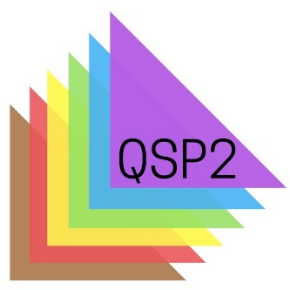  contactqsp2@gmail.com | QSP2 supports LGBTQ students and their allies. The group offers social activities, advocates for LGBTQ rights and services in the School of Social Policy & Practice, and serves as a group within the University-wide network of LGBTQ organizations at Penn. QSP2 aims to infuse LGBTQ content into SP2 curricula, build coalitions with other organizations, increase visibility of LGBTQ SP2 students, and provide emotional and social support for Penn’s LGBTQ community.

