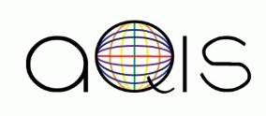  aqis.upenn@gmail.com  @aqis.upenn | AQIS (Association for Queer International Students) is Penn's only student group catered for the needs of queer students from global backgrounds. AQIS provide mentorship, plan social events, and promote discussion about international queer issues.
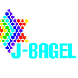  upennjbagel@gmail.com  @pennjbagel | J-BageL (Jewish Bisexuals, Gays, and Lesbians) is a safe space and social support group for Jewish LGBTQ undergrad and grad students and their allies. Funded by Hillel of Greater Philadelphia, J-BageL has members from Penn and other colleges throughout the Philadelphia area.
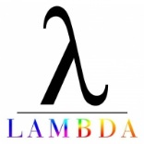  lambdaalliance.upenn@gmail.com  @pennlambdaalliance | The Lambda Alliance is the coalition dedicated to the promotion and representation of LGBTQIA interests for undergraduates at Penn. By facilitating communication, collaboration, and efficiency among its constituent groups, the wider student and Philadelphia communities, and the University administration, the Lambda Alliance seeks to overcome the barriers facing the LGBTQA student community of today.
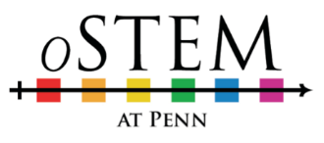  ostematpenn@gmail.com | oSTEM at Penn is a chapter of Out in Science, Technology, Engineering & Mathematics, the national student society dedicated to increasing participation of people who identify with lesbian, gay, bisexual, transgender, queer, or ally (LGBTQA) communities in disciplines related to science, technology, engineering, or mathematics (STEM).
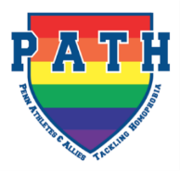  upennpath03@gmail.com  @UPennPath | PATH (Penn's Athletes & Allies Tackling Homophobia) is a group addressing the mutual concerns of Penn's LGBTQ and athletic communities. As a group, PATH also provides resources for those in the athletic community who wish to come out, and for heterosexual athletes and coaches to receive accurate information about LGBTQ issues.
pennsaces@gmail.com  @PennAces | PennAces is a student organization that promotes awareness, education and safety for the asexual community in Philadelphia. Asexuality—not experiencing sexual attraction—is an orientation that is not given enough attention in our society, though 1% of the population  openly identifies as asexual.
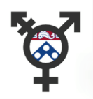  pennnoncis@gmail.com  @pennnoncis | Penn Non-Cis is a student-run organization that serves trans students (graduate and undergraduate), staff, and other people in the Penn Community. Non-Cis is short for Non-Cisgender, which is a term that we use to encompass transgender, gender non-conforming, and questioning people."
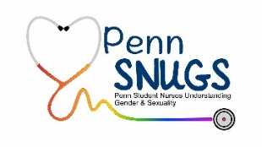  PennNursesPUSH@gmail.com  @PennSNUGS | Penn SNUGS (Student Nurses Understanding Gender and Sexuality) is Penn Nursing's student organization aimed at both increasing quality LGBTQ (Lesbian, Gay, Bisexual, Transgender, & Queer) patient care and awareness, as well as promoting a supportive community for LGBTQ identified nursing students.
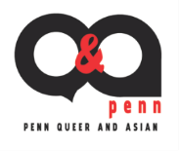  pennqanda@gmail.com  @pennqanda | Penn Q&A (Penn Queer and Asian) is dedicated to providing a safe space for both support and empowerment of LGBTQ+ individuals in the Asian community at Penn. You don't have to be queer or Asian to join if you're interested in addressing issues of the queer Asian community.
pennqcf@gmail.com  @pennqcf | Queer Christian Fellowship (QCF) is a supportive, welcoming Christian community for individuals who want to explore the intersection between faith, sexuality, and gender. We seek to provide support, fellowship, a space for discussion, and resources for our members, Penn, and the community at large while establishing connections with groups of similar interests.
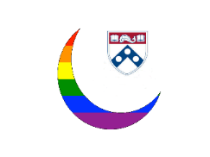  qmapenn@gmail.com  @QMAPenn | QMAP (Queer Muslims and Allies at Penn) is a student group aimed at providing support for Penn’s LGBTQI Muslim community and allies of all faiths, sexual orientations, gender identities, and cultural backgrounds. In our eyes, the term "Muslim" may encompass anyone who identifies with any form of Islam in any capacity, whether religiously, culturally,  by familial association, or otherwise. All are welcome.
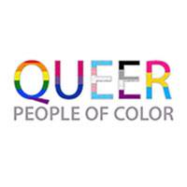  qpoc.upenn@gmail.com  @QueerPeopleofColor –  QPOC UPenn | QPOC (Queer People of Color) at University of Pennsylvania serves students of color who identify as lesbian, gay, bisexual, transgender and/or queer (LGBTQ) by providing them with safe spaces for discussion, socialization, and community building
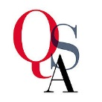  pennqsa@gmail.com  @pennqsa | QSA (Queer Student Alliance) at the University of Pennsylvania is a group of undergraduate students who identify as or are supportive of gender identity or sexual minorities. The Queer Student Alliance strives to support these communities through facilitating social  and community-oriented activities.
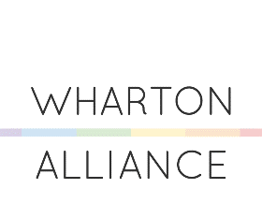  whartonalliance@gmail.com  @WhartonAlliance | Wharton Alliance is the first LGBTQ pre-professional undergraduate organization in the United States. They are dedicated to educating Penn undergraduates about the opportunities that exist  in the business world for LGBTQ students.

